Final Report

**on**

**DEVELOPMENT OF COMMERCIALLY VIABLE PRAWN POST LARVAE PRODUCTION TECHNIQUE IN POND**

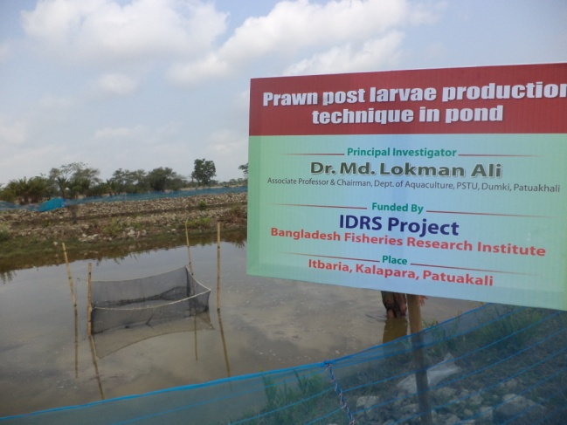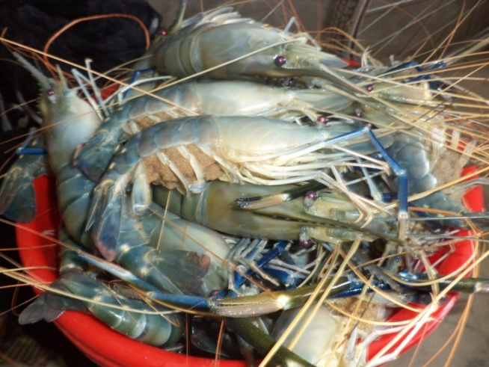

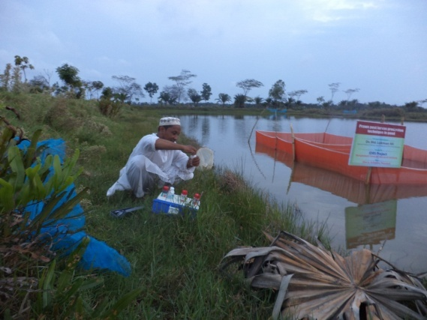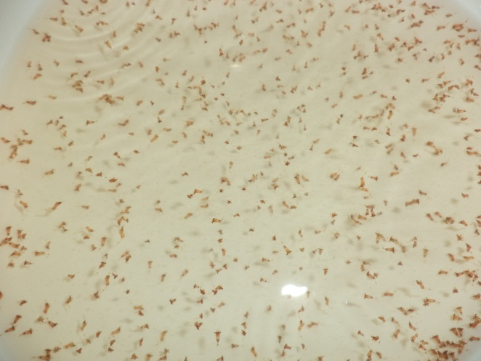

Submitted to

Project Director

IDRSBFRI Project

Bangladesh Fisheries Research Institute

Shrimp Research Station, Bagherhat-9300

Project Duration

July 2012 to June 2014

Submitted by

Dr. Md. Lokman Ali

Department of Aquaculture

Patuakhali Science and Technology University

Dumki, Patuakhali- 8602

**FINAL REPORT (July 2012 To June 2014)**

1. **Project Title:**

**Development of commercially viable prawn post larvae production technique in pond**

1. **Implemented Organization:**

Faculty of Fisheries, Patuakhali Science and Technology University

1. **Funded By:** IDRS-BFRI, Bangladesh Fisheries Research Institute, Shrimp Research Station, Bagherhat-9300.
2. **Name of PI/CIs:**

(a) **Principal Investigator**

Name: Dr. Md. Lokman Ali

Position: Associate Professor & Dean

Faculty of Fisheries, PSTU

Mobile: +88 01716379131

E-mail: lokman.fri@gmail.com

(b) **Co-investigators-1**

Name: **Sibnath Pattadar**

Position: Assistant Professor

Department of Aquaculture

Faculty of Fisheries, PSTU

(c) **Co-investigators-2**

Name: **Kaniz Ruksana Sumi**

Position: Assistant Professor

Department of Aquaculture

Faculty of Fisheries, PSTU

(d) **Co-investigators-3**

Name: **Md. Rushna Alam**

Position: Lecturer

Department of Aquaculture

Faculty of Fisheries, PSTU

1. **Project Duration: July 2012 to June 2014**
2. **Total Approved Budget:** Tk. 11,00,000 (Eleven Lakh Taka Only)
3. **Total Expense:** Tk. 11,00,000 (Eleven Lakh Taka Only)

**Background:**

Prawn culture in the country, is being developed in and around the coastal areas, depending on naturally collected seeds. Though only few prawn hatcheries are being operated, their production rate is not consistent and far below the country’s requirement. This means the pressure on natural resources are growing, resulting of shortages in natural seed supply. In addition, intensification of prawn culture in existing farms and further expansion in new farms would increase the demand for post-larvae.

Now a days prawn hatchery are facing a lot of problems in Bangladesh. In recent years many prawn hatchery are closed due to various problems such as low price of PL, shortage of experienced technical manpower, heavy mortality because of disease etc. Due to the increase of prize of feed, chemical, labour and other imports production cost of PL is increasing day by day. In 2012 prize of *Artemia* cyst is about 44000.00Tk/carton whereas in 2011 it was only 22000.00 Tk/carton. *Artemia* cost is a main cost in prawn hatchery. Market price of PL is not increased regarding the increase of production cost. This is why all prawn hatchery owners are in vulnerable economic condition and they are losing their interest about prawn hatchery. As prawn seed supply is insufficient compared to the requirements of our country, farmers are depending on natural PL. During the collection of natural PL many larvae of important aquatic organism are destroying. As a result coastal biodiversity is in vulnerable condition.

So, this is the time to think about the alternate PL production technique of freshwater prawn. If we are able to produce freshwater prawn PL in pond that would be bring a great opportunity to supply low cost and sufficient amount of PL for prawn farming. This technology also help us to save the import cost because air blower, generator, thermostat water heater, *Artemia* and chemicals are imported from other country. On the other hand, hatchery PL are often contaminated by different harmful chemical and antibiotic but pond PL was free form harmful chemical and antibiotic. With this view, the present research project is being proposed to develop a sustainable technology of prawn PL production in pond

**3.1. Broad objective(s)**

The broad objective of the project is to produce low cost and chemically contaminated free viable PL in pond.

**3.2. State specific objective(s) succinctly, in the order in which they was achieved.**

* To develop a sustainable and commercially viable prawn PL production technology in pond.
* To produce low cost and chemically contaminated free viable PL.
* To optimize the stocking density of prawn larvae in larvae rearing pond (LRP).
* To determine the suitable feed for prawn larvae in LRP.

**Materials and Methods:**

**Study-1: Optimization of stocking density of prawn larvae in larvae rearing pond (LRP)**

**a. Description of the Study Area**

The experiment was carried out at Kuakata upazilla of Patuakhali district. Nine special type pond of 3-4 decimal was used for this experiment. Ponds was situated near the river of saline water. Saline water was collected from river by pump and freshwater was collected from underground sources.

**b. Experimental design**

The experiment had three treatments. The treatments were T1 (stocking density 10,000/m3), T2 (density 12,000/m3), T3 (density 15,000/m3). Each treatment had three replications and assigned into a completely randomized design.

**c. Pond preparation:**

Pond embankment, inlet, outlet was repair to increase the suitability of pond for larvae rearing. Then the ponds was enclosed by filter net to prevent the any type of predator. Saline water was collected from adjacent river through a filter bag to remove any solid material and predator of water by using submersible pump. Then the saline water was kept in a holding pond for settling down. After settling down the saline water was transferred into larvae rearing ponds (LRP). Then freshwater was mixed with saline water to prepare 12 ppt water in water. Water of the ponds was treated with lime (1 kg/dec.) and the fertilized with triple super phosphate (75g/ dec.) and urea (150g/dec).

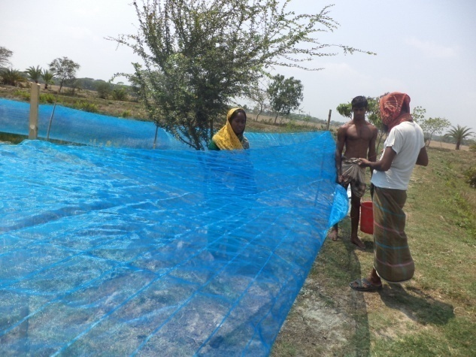 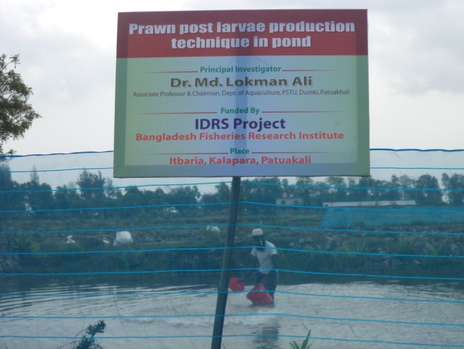

d. Disinfection of Saline water

Saline water (12 ppt brakish water) was bleached with 60% chlorinated bleaching powder at a dose of 12 ppm and aeration was performed for 24h to kill all types of disease producing organisms such as protozoan parasite, bacteria, virus, fungus etc. After one day, these salt water was treated with 12 ppm sodium thio-sulphate and air was blown for one day to remove the chlorine of bleaching powder because chlorine is harmful for prawn larvae.

e. Preparation of hatching pond:

The salinity of Pira river at Amtoli point from where we have collected the brood was 0-1ppt and the salinity of larvae rearing pond was 12ppt. For this reason we were used a pond with 6 ppt saline water for hatching of gravid female eggs. This pond was also prepared using above protocol.

f. Brood collection and stocking of brood in hatching pond:

Female prawn bearing gray and dark yellow coloured eggs was collected from pira and biskhali rivers of Borgona district and transferred to experimental pond by using plastic drum and pick-up van. Grading of brood prawns was performed according to the colour of eggs because the hatching time depends on the colour of eggs. Gray colour eggs was hatched within 1-3 days but the hatching time of yellow is 5-10 days. Then brood prawns was kept in the hatching hapa set up in LRP for hatching after 10-15 minute treatment in 20 ppm formalin solution for minimizing any contamination. Hatching hapa was provided with shelter to avoid cannibalism. Broods was fed by rice and egg custard regularly.

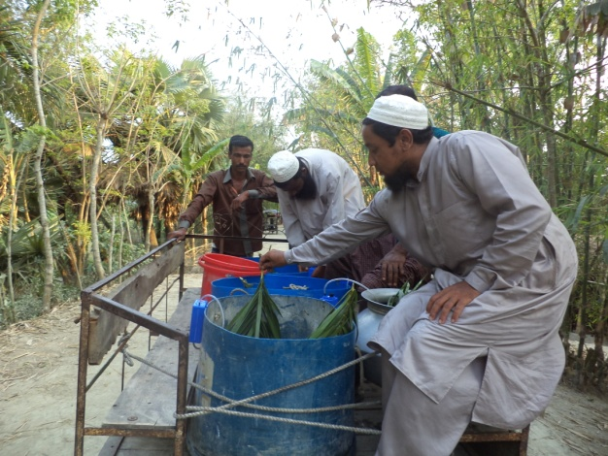 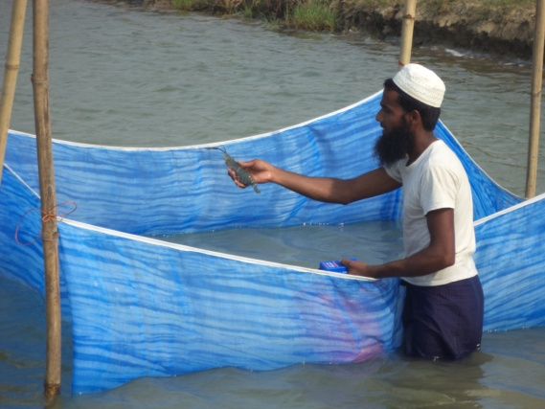

**f. feeding:**

Egg custard and yeast was used as larval feed. Egg custard was prepared by using of different nutritional ingredients. The ingredients of egg custard are given bellow:

**Table. Ingredients of egg custard**

|  |  |
| --- | --- |
| **Ingredients** | **Amount** |
| Powder milk | 30% |
| Egg | 35% |
| Cornflower | 10% |
| Prawn | 20% |
| Agar powder | 2% |
| Cod liver oil | 1.5 % |
| Vitamin premix | 1% |
| Oxytetracycline | 0.5% |
| **Total** | **100%** |

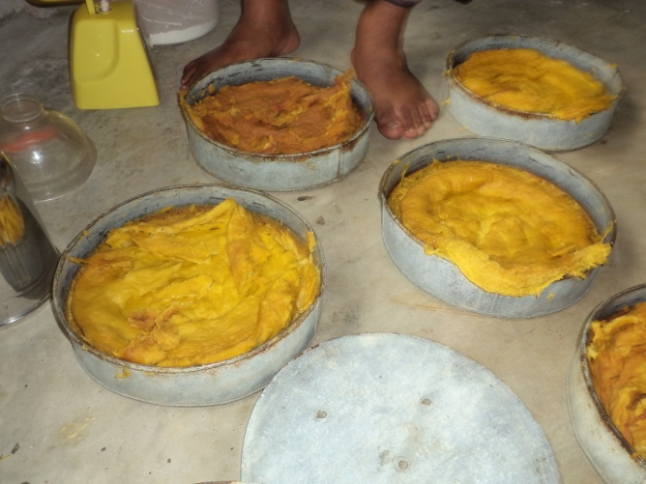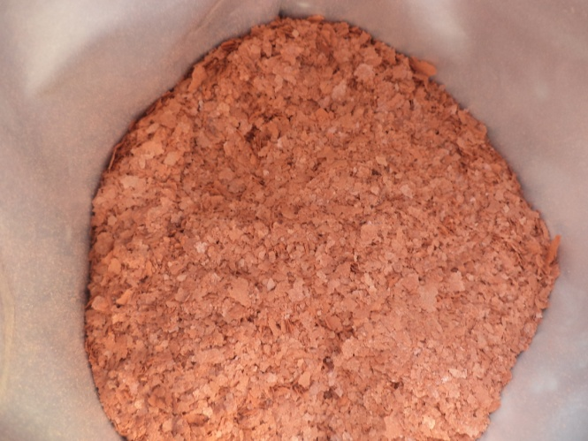

Powder milk was used as a protein source as well as to increase the palatability of custard. Egg and prawn was used as protein source and cornflower was used as carbohydrate source. The ingredients was mixed with a blender and put into a aluminum pot. Then boiled for 30 min. to make a cake. The cake of custard was cut into a small pieces. Then the pieces of egg custard was passed through small mesh net to make them smaller size. Egg custard particles was washed to remove liquid materials. The smaller particle sized custard was fed to smaller larvae and as the larvae grew up the custard particle size also increased. Brine shrimp flake also used as feed.

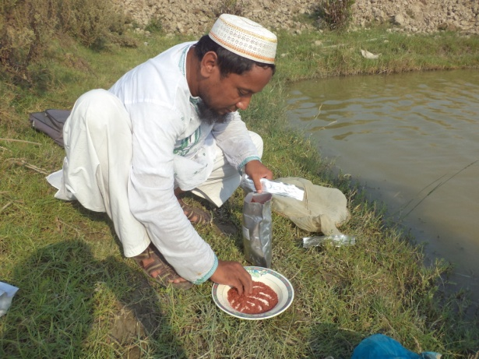 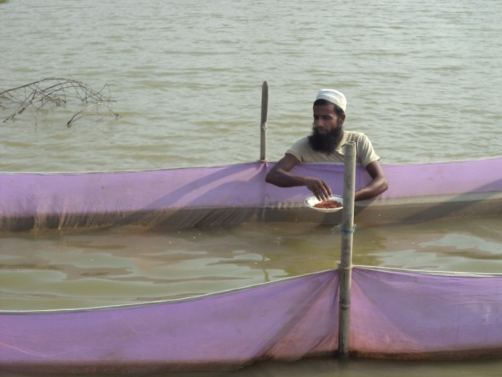

**Health management:**

Larval health condition was checked twice daily. During health checking the following things was observed:

1. Larval movement, either normal or abnormal
2. Larval body color, either brownish or reddish or fade.
3. Feeding condition, either larvae fed normally or not.
4. Aggregation of larvae, either larvae aggregated in one place or scattered.
5. Mortality of larvae.

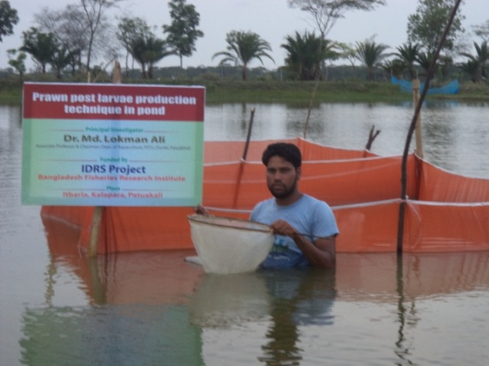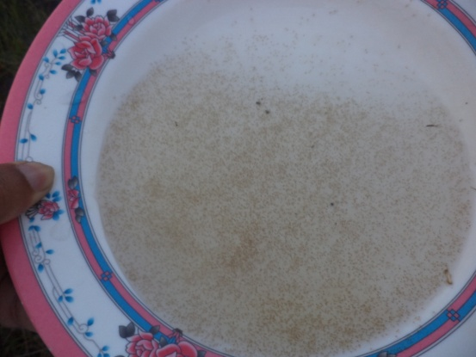

If any abnormality of larvae was observed, some larvae was collected from the LRP and taken to the laboratory of Patuakhali Science and Technology University for microscopic examination. Different antiseptic agent such as formalin, protosite, liquid iodine and antibiotic such as oxytatracycline was used for disease control. HACCP (Hazard Analysis Critical Control Point) and biosecurity procedure were maintained to prevention of disease.

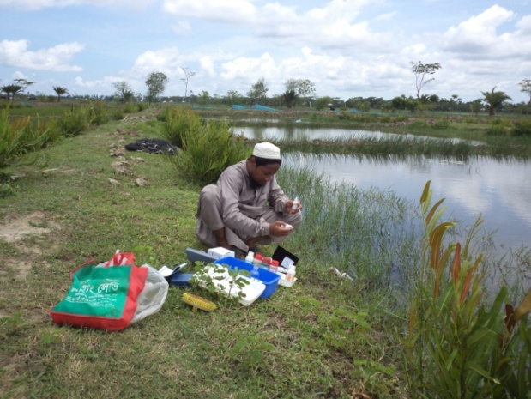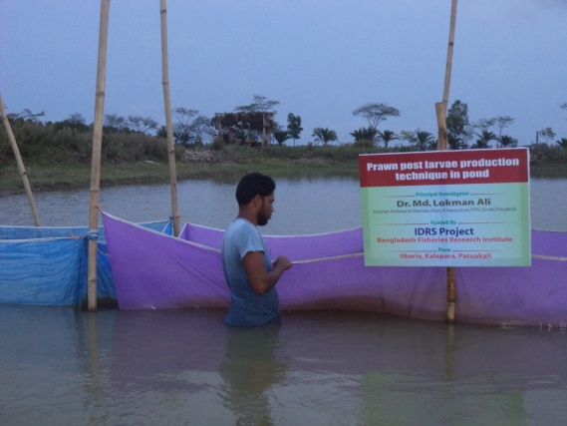

**Study of Water quality parameters**

Water quality parameters of the experimental pond was weekly recorded throughout the study period. Physico-chemical parameters, such as water temperature (°C), dissolved oxygen (mg/L), pH, ammonia (mg/L), nitrite (mg/L) and alkalinity (mg/L) was measured in hatchery. Water salinity was observed by using refractometer. Salinity was maintained at 12 ppt. Any increase in salinity through evaporation was corrected by adding freshwater.

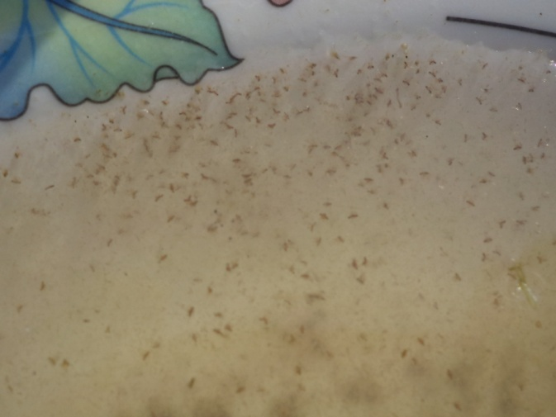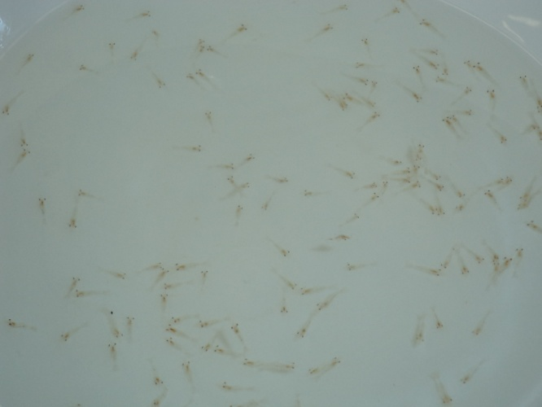

**Harvesting of Post larvae (PL)**

There are eleven larval stage of prawn larvae up to post larvae. Prawn larvae was stocked at first stage. They was reared up to PL. The larvae was reared up to post larval stage (PL), when they took the shape of adult prawn and started swimming, changing from backward to forward movements and changing from upside to normal position, it is called metamorphosis. Fresh water prawn larvae need 12 ppt saline water for their growth and survival but PL don’t need saline water. They can easily survive at fresh water. So, when prawn larvae change into post larvae through metamorphosis, saline water of larvae rearing pond was gradually transfer into fresh water through discharged and addition of water within two days. At the end of the experiment, all post larvae was harvested and counted to find out the survival rate. It was calculated as:

Survival rate (%) = 

**RUSULTS**

**Water Quality Parameters**

The average value of water quality parameters viz., water temperature, dissolved oxygen (D.O.), pH, alkalinity, NH3 and NO2 and under different treatments are shown in Table 3.4.

**1. Water Temperature**

The ranges of water temperature in different treatments during the study period were more or less similar which was between 29.2 – 31.9°C, the mean values of water temperature in T1, T2 and T3 were 31.18 ± 0.95°C, 31.10 ± 0.42°C, 31.52 ± 0.41°C respectively (Table 3.4). Weekly variation of water temperature in different treatments are shown in Figure 3.8. Water temperature of all treatments gradually increased up to 21 days and then decreased at 28 days and further increased and decreased occur due to changes of weather temperature.

**2. Dissolved Oxygen (mg/L)**

The ranges of dissolved oxygen in different treatments during the study period were found to be more or less similar and were between 5.65 –7.40 mg/L. The mean values of dissolved oxygen concentration were 6.16 ± 0.12 mg/L in T1, 6.24 ± 0.13 in T2, 6.18 ± 0.21 in T3 (Table 3.4). Weekly variation of DO in different treatments are shown in Figure 3.9. The dissolved oxygen contents more or less same in all treatments. In some treatment DO concentration gradually increased with the time and in some treatment gradually decreased due to the temporary failure of aeration system in particular larvae rearing tank.

**3. pH**

The ranges of water pH in different treatments during the study period was found between 7.70 - 8.65. The observed mean values of pH were 8.16 ± 0.37, 8.12 ± 0.26, and 8.35± 0.14 in T1, T2 and T3 respectively (Table 3.4). Weekly variation of pH in different treatments are shown in Figure 3.10. The pH values of experimental tanks were increased and decreased haphazardly. The pH values were increased due to metabolic activity of larvae and decreased due to water exchanged of culture tank.

**4. Alkalinity**

The range of alkalinity in different treatments during the study period was between 121 - 191 (Table 3.4). The mean values of alkalinity in T1, T2 and T3 were 147.5±2.12 (126-177); 155.3±2.61 (129-191); 143.7±2.15 (121-172); respectively (Table 3.4). Weekly variation of alkalinity in different treatments are shown in Figure 3.11. Alkalinity of different larvae rearing tanks were more or less same and slightly increasing with time

**5. Ammonia**

The range of ammonia nitrogen in different treatments during the study period varied from between 0.17 - 0.32. The mean values of ammonia in T1, T2 and T3 were 0.25 ± 0.02, 0.21 ± 0.03 and 0.24 ± 0.03, respectively (Table 3.4). Weekly variation of ammonia in different treatments are shown in Figure 3.12. Ammonia concentration of larvae rearing tanks were gradually increased in most treatment but in some case decreased. Ammonia gasses were increased due to metabolic activity of larvae, decomposition of egg custard and decreased due to water exchange.

**6. Nitrite (No2)**

The range of nitrite in different treatments during the study period was between 0.37 - 0.91. The mean values of ammonia in T1, T2 and T3 were 0.63 ± 0.06, 0.67 ± 0.03, and 0.65 ±0.03 respectively (Table 3.4). Weekly variation of nitrite in different treatments are shown in Figure 3.13. Nitrite concentration of larvae rearing tanks were gradually increased in all treatment. Nitrite gasses were increased due to metabolic activity of larvae, decomposition of egg custard.

**Table. Water quality parameters during study period (mean and range)**

|  |  |  |  |
| --- | --- | --- | --- |
| **Parameters** | **T1 (mean ± SE)** | **T2 (mean ± SE)** | **T3 (mean ± SE)** |
| Water Temperature  (°C) | 31.18 ± 0.95 °C (29.2 – 31.7°C) | 31.10 ± 0.42°C (29.4 – 31.5°C) | 31.52 ± 0.41°C  (29.5 – 31.9°C) |
| Dissolved Oxygen (mg/L) | 6.16 ±0.12  (5.65 –7.30) | 6.24 ±0.13  (5.86 –7.23) | 6.18 ±0.21  (5.92 –7.40) |
| pH | 8.16 ± 0.37  (7.70-8.32) | 8.12 ± 0.26  (7.8-8.65) | 8.35± 0.14  (7.82-8.52) |
| Alkalinity (mg/L) | 147.5±2.12  (126-177) | 155.3±2.61  (129-191) | 143.7±2.15  (121-172) |
| Ammonia (mg/L) | 0.25 ± 0.02  (0.17 - 0.31) | 0.21 ± 0.03  (0.18 - 0.28) | 0.24 ± 0.03  (0.19 - 0.32) |
| Nitrite (NO2) (mg/L) | 0.63 ± 0.06  (0.46-0.87) | 0.67 ± 0.03 (0.37-0.91) | 0.65 ±0.03  (0.42-0.89) |



**Fig. 1. Variation of temperature within three treatments during experimental period.**



**Fig. 2. Variation of dissolved oxygen** **within three treatments during 42 days of observation.**



**Fig. 3. Variation of pH within three treatments during 42 days of observation.**



**Fig. 4. Variation of alkalinity (mg/l)** **within three treatments during 42 days of observation.**



**Fig. 5. Variation of ammonia (NH­3) within three treatments during the study period.**



**Fig. 6. Variation of nitrite (mg/l)** **within three treatments during 42 days of observation.**

**Survival Rate**

In 2012-2013 prawn larvae were reared up to 10 days because Cyclone Mohasen was attacked after 10 days of larvae stocking and all research activities was destroyed. Salinity low down from 12 ppt to 5 ppt due to heavy rain fall. As a results all larvae were died.

In 2013-14 all ponds were re-excavated and research activities were start timely. At first larvae were stock directly in the pond. After 16 days all larvae were died due to excess sunlight and high temperature (35°C). Then we provided sufficient amount of shelter and shed and restock the larvae in ponds at 10/l. After 35 days larvae changed into post larvae after metamorphosis but survival rate was 12%.

Then we setup nine glass nylon hapa in three ponds and stock larvae at different stocking density- T1 (stocking density 10,000/m3), T2 (density 12,000/m3), T3 (density 15,000/m3). Rearing period was 40 days. Metamorphosis start at 21th day and completed 35th day in T­­­­­1, start at 24th day and completed 38th day in T­­­­­2, start at 26th day and completed 39th day in T­­­­­3. The culture period of larvae up to post larvae (metamorphosis) were more or less same.

The results of this experiment is given bellow:

**Table 2.** **Production of *M. rosenbergii* post larvae reared on different combinations of brine, crude salt and table salt solution**

|  |  |  |  |  |  |
| --- | --- | --- | --- | --- | --- |
| **Treatment** | **Larvae**  **stocked/** m3 | **Days of metamorphosis** | | **Post-larvae/** m3 | **Average survival rate (mean ± SE) (%)** |
| **Start** | **Complete** |
| T­­­­­1 | 10,000 | 21 | 35 | 3532± 245 | 35.32± 5.80a |
| T­­­­­2 | 12,000 | 24 | 37 | 3873 ± 220 | 32.28± 4.34a |
| T3 | 15,000 | 26 | 39 | 3849 ± 310 | 25.66 ± 4.45a |

Conclusion: Treatment 1 showed best results. In case of higher stocking density more catabolism occur. From 2 years research results we may be concluded that hapa is the best for prawn PL production in pond. Now this technology will be disseminate among the coastal farmers. By this technology we can easily improve their livelihood status as well as increase prawn production.



Dr. Md. Lokman Ali

Associate Professor & Chairman

Department of Aquaculture

Dean

Faculty of Fisheries, PSTU

Mobile: +88 01716379131

E-mail: lokman.fri@gmail.com